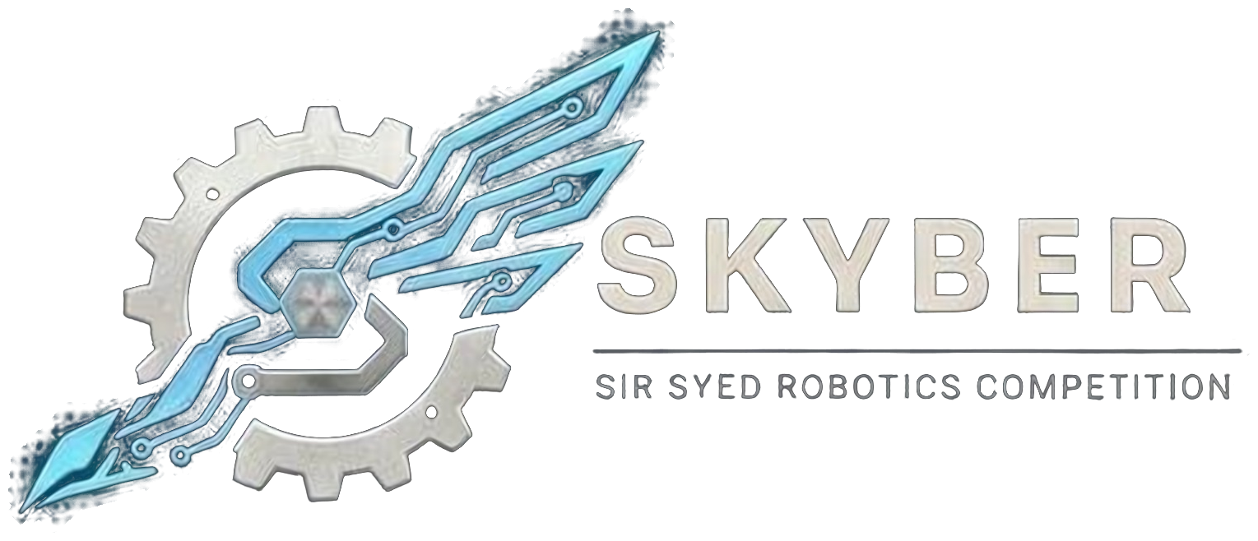 | SIR SYED ROBOTICS COMPETITION  SKYBER 2026 | SSUET | OFFICIAL RULEBOOK | 

GAMING MODULE: FIFA 26, TAKKEN 8 AND PUBG PC TOURNAMENT: OFFICIAL RULEBOOK
🎮 UNIVERSITY GAMING COMPETITION
General Event Rules & Regulations
1. Punctuality: All participants must arrive at the designated venue on time according to their respective match schedules.
2. Disqualification: If a participant is unavailable when their scheduled match is called, they will be automatically disqualified, and their opponent will advance to the next round by a walkover.
3. Match Timings: Participants are strictly advised to follow the provided match schedules and timings to ensure the smooth management of the competition.
4. Code of Conduct:
- The use of abusive, offensive, or inappropriate language during matches or anywhere at the event venue is strictly prohibited. Violation of this rule may result in immediate disqualification.
- Cheating, hacking, game exploits, match-fixing, collusion and the use of unauthorized tools mean immediate disqualification
- Communication during a round is by voice or chat within the team only. Any communication with spectators or outside people is prohibited.
- Communication during a round is by voice or chat within the team only. Any communication with spectators or outside people is prohibited.
- Organizers have the final say on rule violations, disputes and match results.
5. Volunteer Instructions: All participants must cooperate with and follow the instructions provided by event volunteers and organizers.
6. Eligibility: Participation for FIFA 26 and T8KKEN 8 is exclusively open to university and college students only and PUBG is open to all School ,Colleges and University students
7. The tournament will follow a knockout format, where winners will advance to the next round until the final winner is decided.

⚽ FIFA 26 – Game Rules
1. Game Format: All matches will be played in a Solo vs. Solo format. Team participation is not allowed.
2. Match Duration: Each match will consist of two halves, with 6 minutes per half, making the total match duration 12 minutes.
3. Team Selection: Participants are free to choose any team of their choice. There are no restrictions on team selection.
4. Entry Fee: Rs 1000.
🥊 TEKKEN 8 – Game Rules
1. Game Format: All matches will be played in a Solo vs. Solo format. Team participation is not allowed.
2. Match Format: Each match will consist of 3 rounds.
All participants are requested to read and understand the rules carefully before registering. Failure to follow the competition rules and regulations may result in disqualification.
3. Entry Fee: Rs 1000.
PUBG PC – Game Rules
- Game Format: It’s a team game each team will consist of 4 players
- Roster: Team members cannot be added or changed after registration closes on 16 November 2026. Students from different institutions may join one team.
- Captain: Each team names one captain at registration. The captain is the only person who may speak to referees.
- ID card: Every participant shows a printed ID card at entry. The template is sent with the registration confirmation.
- Entry Fee: Rs 1500 per team.

Game Setup:

Game and version: PUBG only, on the university’s gaming computers. Players do not install their own copies or add-ons.
Server: A LAN server run by the organizers. Players may not connect to outside servers during matches.
Settings: The organizers publish one fixed configuration (mode, round time, buy time, economy and map pool) before registration closes. Every match uses that configuration.
Maps: A map pool is published with the rulebook. Maps are chosen by a veto process: the teams take turns banning maps until one remains.
Hardware: The university provides the computers, monitors, mice and keyboards. Players may bring their own mice and keyboards if the referee approves them.
Anti-cheat and mods: Only the organizer-approved configuration is allowed. Scripts, macros, third-party programs, and any file that changes the game’s behavior are prohibited.

Play Fair. Respect Everyone. Enjoy the Game! 🎮
Date: 18 November 2026
Venue: Sir Syed University of Engineering & Technology (SSUET), Karachi. Room to be announced.
Event: SKYBER 2026
Contact Information:
Contact no.: 03322396805
Participants are advised to follow the official SKYBER 2026 announcements for updates regarding the competition schedule, venue, reporting times and other instructions.

